**PROJECT REPORT TEMPLATE**

**1 INTRODUCTION**

OVERVIEW

Appstrail is a company that specializes in providing digital transformation solutions using salesforce technology for retail salesforce management.

salesforce can be used to create and manage beat plans for filed sales teams.

PURPOSE

salesforce can be used to manage orders from retail stores and distributors, includings tracking orders, processing payments, and managing inventory levels.

This can help field sales teams ensure that orders are fulfilled quickly and accurately and that inventory levels are maintained at optimal levels.

**2 Problem definition & design thinking**

EMPATHY MAP

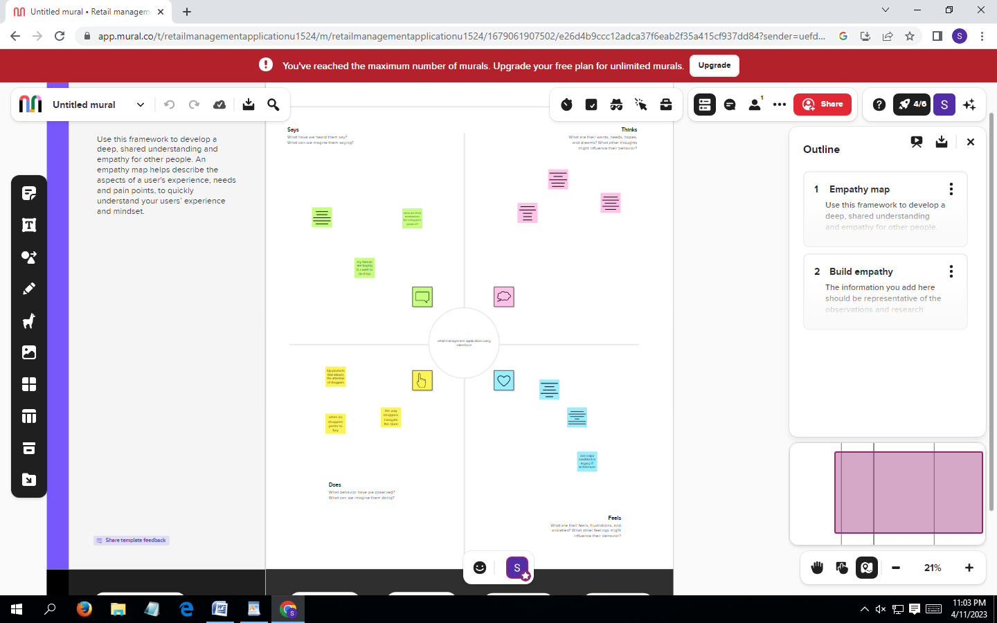

IDEATION & BRAINSTROMING MAP

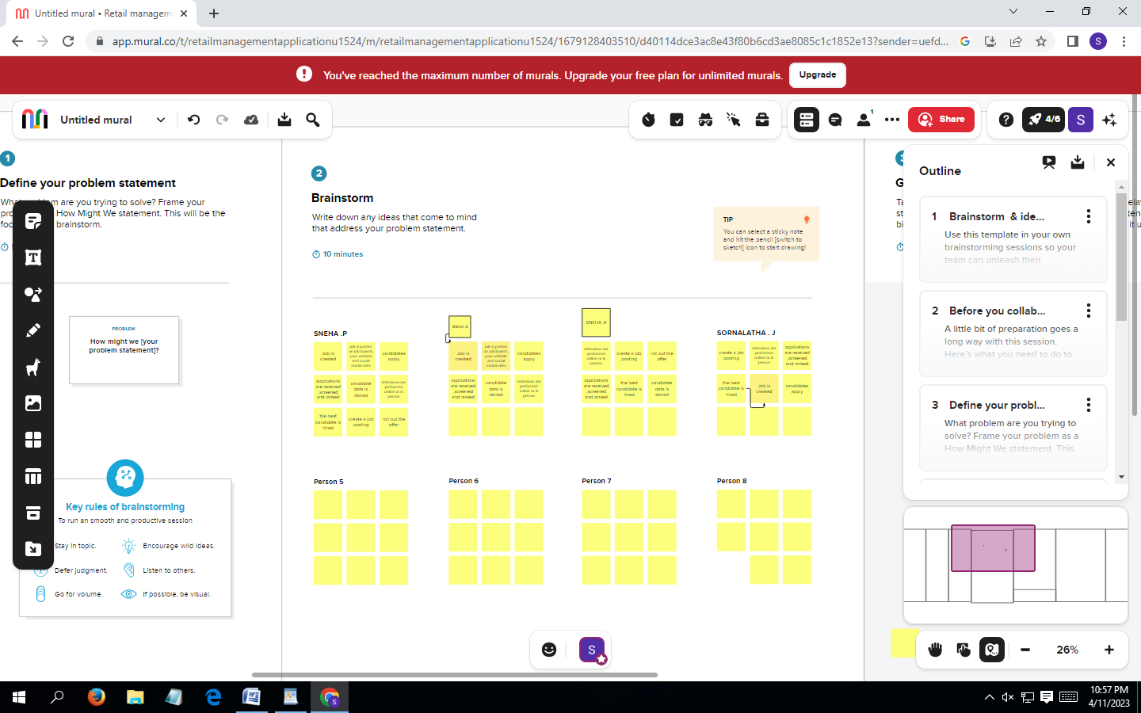

**3 RESULT**

Data model:

|  |  |
| --- | --- |
| **Object name** | **Fields in the Object** |
| Creation of object  Dispatch/Tracking | |  |  | | --- | --- | | Field label | Data type | | Display/tracking | Text | | Display/trackings | Text | |
| Fields Available on Dispatch/Tracking | |  |  | | --- | --- | | Field label Field label Field Field label | Data type | | Dispatched | Text | | Dispatch/Tracking | Text | |

**Activities & screenshot**

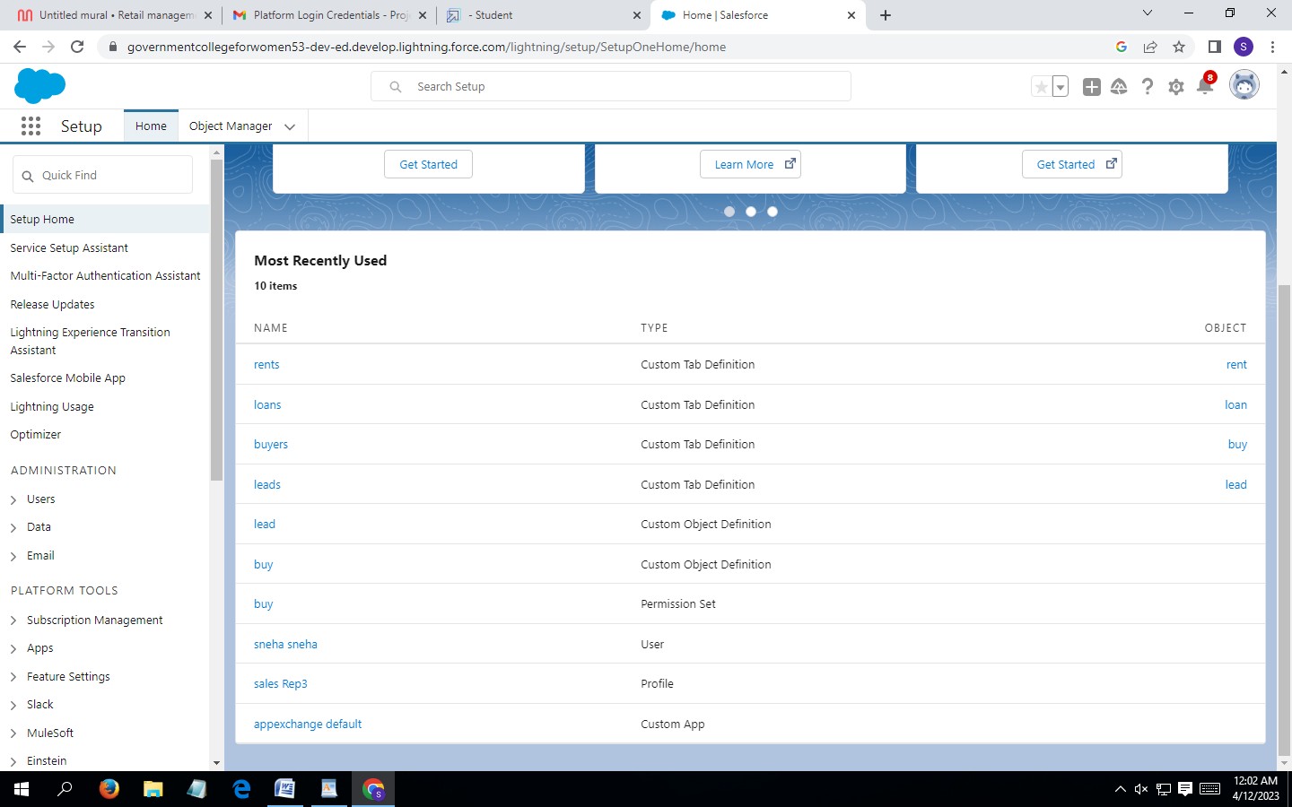

**4 Trailhead Profiles Public URL**

**Team leader -** [**https://trailblazer.me/id/ssneha64**](https://trailblazer.me/id/ssneha64)

**Team member 1 -** [**https://trailblazer.me/id/snehb3**](https://trailblazer.me/id/snehb3)

**Team member 2 -** [**https://trailblazer.me/id/snehr44**](https://trailblazer.me/id/snehr44)

**Team member 3 -** [**https://trailblazer.me/id/sornalathaj20**](https://trailblazer.me/id/sornalathaj20)

**5 Advantages & Disadvantage**

Salesforce is designed to not only provide a significant number of feature out of the box, but is also highly customizable.

Using point-and-cl8ick tools, built-in UI/UX features, and automation, salesforce can quickly be tailred and implemented to meet many use cases, streamline business process, and help organizations become more efficient.

With such a flexible, customization platform ,it can be easy to build in too much customization and some integrations come with limitations.

Working with an implementation partner like higher Echelon can help your orgawnisation determine how to prioritize needs and get the most out of your salesforce org at a pace and level of customization that is most effective

**6 Applications**

Revolutionise those processes that take time out of your availability for product devlopement , nurturing customer relationsips , an distributring content and products that reflect the high quality of your brand.

**7 Conclusion**

Salesforce is a powerful platform that can help retailers meet the demands of the rapidly changing retail landscape.

**8 Future scope**

Salesforce is a must – have for any retail business looking to stay ahead of the competition.